ECG Signal Analysis

P. Sai Teja

**Introduction:**

The electrocardiogram (ECG) is a test that records the electrical activity of the heart. ECG signals are used in continuous heart rate monitoring of the patient. Some abnormalities observed in ECG signal like T-wave inversion or biphasic t-wave or the variations in the rate of ECG points (RR or QRS) can provide insights about heart condition.

QRS detection is difficult, not only because of the physiological variability of the QRS complexes, but also because of the various types of noise that can be present in the ECG signal. Noise sources include muscle noise, artifacts due to electrode motion, power-line interference, baseline wander, and T waves with high-frequency characteristics like QRS complexes [1]. In this analysis RR peak separation and QRS complex width have been used to extract heart condition from ECG signal data.

A typical ECG signal contains a PQRST complex as shown below which typically represents a heartbeat (cycle of expansion and contraction of heart).

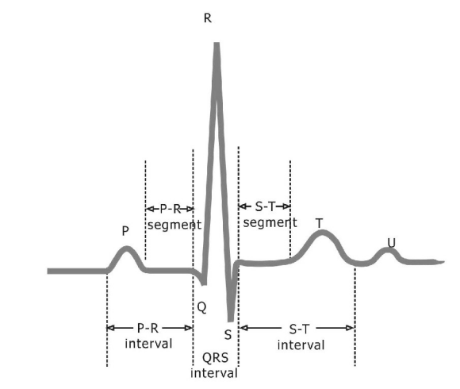

In this analysis we have calculated the time duration between each R peak for calculating the beat duration and BPM (Beats per minute) from it. Later in the next section we discussed about the calculation of QRS interval (refer above figure).

Algorithm [1] for finding Q, R, S peaks follows the following stages:

1. Linear processing
2. Non-linear transformation
3. Decision rule algorithm

Elaboration of each stage of the algorithm will be done in the next section.

**Algorithm:**

1. First dc component is removed from the data and normalised to 1.
2. The resultant signal is passed through a band pass filter (cascade of low pass and high pass filter).
3. Then the resulting signal is passed through a M point derivative filter.
4. This signal is squared point by point.
5. An N point moving window integrator is applied to identify location of QRS complex.
6. A threshold is considered to remove the remaining baseline wander energy after filtering and the energy from T complex. The signal above this threshold gives QRS complex’s start and end by considering start as the point where energy changes from below the threshold to above the threshold and end as the point where energy changes from above threshold to below threshold. The delays resulting from derivative and integrator filters have been considered to get the locations of start and end locations.
7. R is detected as the maximum point in the region of start and end of each complex which are found from above.

Q is detected as the minimum point in between start of complex and detected R location.

S is detected as the minimum point in between detected R location and

end of complex.

**Parameters used for the analysis [1]**:

Low pass cut off frequency – 15 Hz.

High pass cut off frequency – 5 Hz.

Differentiator length(M)-5

Moving window integrator length(N)-30

Threshold for QRS complex after integrator-20% of maximum Short term energy.

**Elaboration of each stage of algorithm:**

Linear processing is used to remove the effects of noise sources like baseline wander as specified earlier. Data is cleaned from DC component (mean of the signal) and normalised with respect to maximum of the signal.

ECG with digital bandpass filter improves the signal-to-noise ratio and permits the use of lower thresholds than would be possible on the unfiltered ECG. This increases the overall detection sensitivity.

The high slope (sharp change in signal value) of the R wave is a popular signal feature used to locate the QRS complex in many QRS detectors. A derivative filter is used to extract this information.

After derivative filter point to point squaring is done to intensify the slope information and to reduce false-positives from T-wave slope information.

A moving window integrator is employed on the resulting output which gives information about the possible region of occupancy of QRS complex which is simply getting short time energy for a set of samples and analysing the region with energy above a certain threshold. From there on we can proceed to detect the Q, R, S locations as elaborated in the previous algorithm section.

**Analysis of output of each stage**

The below analysis is upon **ecg1.txt** dataset for the first few QRS complexes.









As we can see here that the noise has clearly reduced, particularly in the P, T, U regions and perfect peaks are visible.



As expected, the derivative filter is giving spikes at high slope variations.

For every QRS complex there are two peaks which represents Q-R slope and R-S slope as the peaks due to T are diminished(which are present root of these two peaks).



The width of the graph depends on the length of the integrator and QS width. So, it should be selected in such a way that it doesn’t interfere with other QRS complex.



Plotting all stages at one place to observe the effect of each stage.



As we can observe the complex (stage 1) is perfectly present in each trapezoid of moving window integration output.

**Heartbeat Rate:**

Histogram of the time difference between each R peak occurrence



BPM=60/ RR peak difference.



Most of the time BPM is around 75. BPM is in the range of healthy person (60 – 100 BPM).

RR change in fraction



Since the algorithm requires RR change to be 166% of average RR change. This change is satisfactory.

The normal range for the change in consecutive RR intervals on an electrocardiogram (ECG), also known as heart rate variability (HRV), should not exceed 10% of the average of those intervals. So, the data seems to be of healthy person.

**Anomalies found in the signal:**

A normal T wave has only positive deflection. A biphasic T wave on an electrocardiogram (ECG) is a T wave that has both a positive and negative deflection. This means that the T wave initially goes upwards (positive deflection) and then downwards (negative deflection) or vice versa. The observed anomaly looks like a biphasic T wave.

**Analysis upon ecg2.txt dataset:**

**Anomalies:**

Biphasic T wave is observed.





Abrupt change in amplitude levels and no S and T wave artifacts are found in the above part of the signal. This can be disease named Arrhythmia.

Arrhythmia refers to any abnormality in the heart's rhythm or electrical activity. The heart normally beats in a regular pattern, which is coordinated by electrical signals. In arrhythmia, the electrical signals may be irregular or disorganized, resulting in a heartbeat that is too fast, too slow, or irregular.

No QRS complex observed in the rhythm it has to occur





Even though the algorithm is able to provide locations of Q and S, the signal doesn’t have decent variations at Q and S locations.

**Heartbeat Rate:**





The heart rate of human must be around 60-100. The above graph clearly represents a false data. The abnormality in the above BPM graph might be due to false identification of T wave as R peak or wrong QRS complex detection due to biphasic T wave’s negative deflection being detected as Q wave.



Since the algorithm requires RR change to be 166% (<= 1.6 fraction) of average RR change. Since the graph is not in that range algorithm will not perform satisfactorily.

The normal range for the change in consecutive RR intervals on an electrocardiogram (ECG), also known as heart rate variability (HRV), should not exceed 10% of the average of those intervals. So, the data seems to be of an unhealthy person.

**QRS interval detection:**

The QRS interval on an electrocardiogram (ECG) represents the duration of ventricular depolarization (contraction) and typically ranges from 0.06 to 0.10 seconds (60 to 100 milliseconds). However, the specific range can vary depending on the individual's age, heart rate, and any underlying medical conditions. A prolonged QRS interval may indicate conduction abnormalities, such as bundle branch block or ventricular hypertrophy, while a shortened QRS interval may indicate a pre-excitation syndrome, such as Wolff-Parkinson-White syndrome [2].

**For dataset ecg1.txt:**



Most of the QRS interval sample occur at 0.1 so this seems to be of a healthy person’s data which is at the edge of the limits. Usually, the limit is extended to 0.12 seconds so it can be assumed to be of healthy person.

**For dataset ecg2.txt:**



The QRS interval seems to very close to 0.12 and even some samples occur below 0.06 secs. So, this data is more of an unhealthy person compared to the previous person’s data assuming the equipment measuring data doesn’t have any fault.

**Conclusion:**

The above algorithm performed better when there no abnormalities such as QRS complex missing, biphasic T wave etc.,

The performance of the second dataset decreased compared to first dataset due to the above-mentioned abnormalities. The BPM were out of the bounds due to these abnormalities.

Some of the effects on the measurements due to abnormalities can be resolved by tracking the possible limits in which a QRS complex should occur and backtrack to capture the peak in that interval assuming it as the possible R peak.

From the histograms of RR change, BPM and QRS interval it is evident that the person of the second dataset doesn’t show healthy signs assuming that the measuring ECG signal doesn’t have any fault.

**References:**

[1] J. Pan and W. J. Tompkins, "A Real-Time QRS Detection Algorithm," in IEEE Transactions on Biomedical Engineering, vol. BME-32, no. 3, pp. 230-236, March 1985, doi: 10.1109/TBME.1985.325532.

[2] Huang, H. D., Lin, C. Y., & Kao, C. L. (2020). Analysis of ECG signal feature extraction and classification algorithm for portable monitoring system. International Journal of Environmental Research and Public Health, 17(12), 4324.